EXPERIMENT9:WordEmbeddingVisualizationusingPCA,t-SNE, and UMAP

AIM:
Togeneraterandomwordembeddingsforasamplecorpusandvisualizethemusing three dimensionality reduction techniques: Principal Component Analysis (PCA), tDistributed Stochastic Neighbor Embedding (t-SNE), and UMAP.

PROCEDURE:
- Importnumpy,re,PCAfromsklearn,TSNEfromsklearn,matplotlib.
- Definesampletextandpreprocessit.
- Buildvocabularyandcreateword2idxmapping.
- Initializerandomembeddingswithdimension5foreachword.
- PCA:ApplyPCA(n_components=2)ontheembeddings.
- t-SNE:ApplyTSNE(n_components=2,perplexity=3)onembeddings.
- UMAP(optional):Applyumap.UMAP(n_components=2)ifavailable.
- Defineplot(data,title):scatterploteachwordwithitslabel.
- PlotPCAandt-SNEresults;tryUMAP,printinstallmessageifunavailable.

CODE:

import numpy as npimport refrom sklearn.decompositionimportPCAfrom sklearn.manifold import TSNE
importmatplotlib.pyplotasplt

text="languagemodelslearnpatternsintextlanguageprocessinghelpscomputers understand language"

defpreprocess(text):
text= text.lower()
text=re.sub(r'[^a-z\s]','',text) return text.split()
tokens=preprocess(text) vocab=list(set(tokens))
word2idx={w:ifori,winenumerate(vocab)}

embedding_dim = 5embeddings = np.random.rand(len(vocab),embedding_dim)

#PCA
pca= PCA(n_components=2)
pca_result=pca.fit_transform(embeddings)

# TSNE tsne = TSNE(n_components=2, perplexity=3) tsne_result = tsne.fit_transform(embeddings)

def plot(data, title): plt.figure() fori,wordin enumerate(vocab):
plt.scatter(data[i,0], data[i,1]) plt.text(data[i,0],data[i,1],word) plt.title(title)
plt.show()

plot(pca_result, "PCA") plot(tsne_result,"t-SNE")

try: import umap reducer = umap.UMAP(n_components=2) umap_result= reducer.fit_transform(embeddings) plot(umap_result, "UMAP")except: print("Install UMAP: pip install umap-learn")

OUTPUT:
[PCA,t-SNE,andUMAPPLOTS-SeeImagePlaceholderBelow]

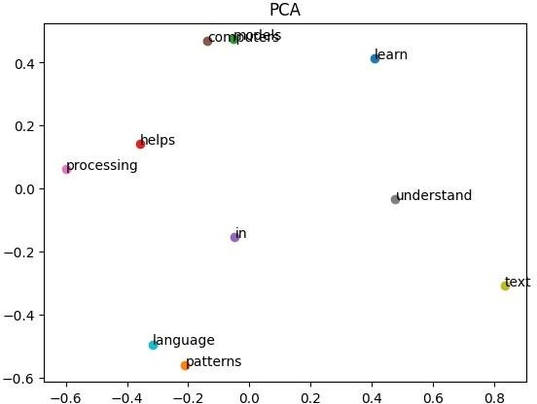

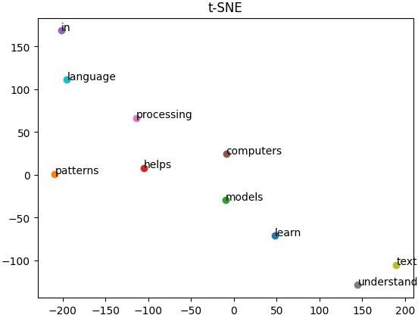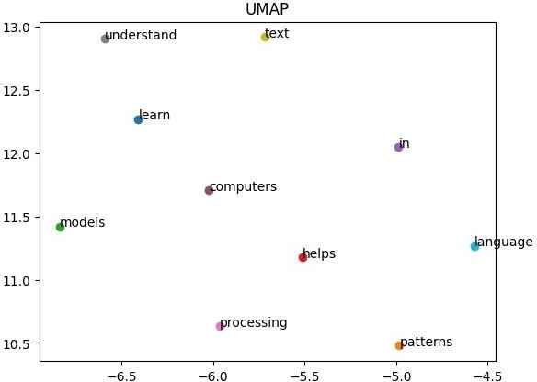

RESULT:
Word2Vecembeddingsweresuccessfullygenerated.Visualizationtechniquesclearly showed word relationships.

